The Ripple Effect: Understanding Interest Rates' Impact on the Housing Market

The housing market in 2023 showcased a level of unpredictability that captured the attention of both economic experts and potential homebuyers. From March to December 2023, the story of the housing market is a mix of ups and downs. Interest rates went up from 6.54% to 7.44%, making it more expensive to borrow money. Even so, people kept buying houses, with sales hitting a high in July with 728 homes sold before dropping a bit towards the end of the year. As for how easy it was for people to buy homes, a score called the affordability index started at 103.5, which is pretty good, but it fell to 91.4 in October, showing that homes were getting harder to afford. These numbers help us see the big picture of what it's been like to buy a house during this time.

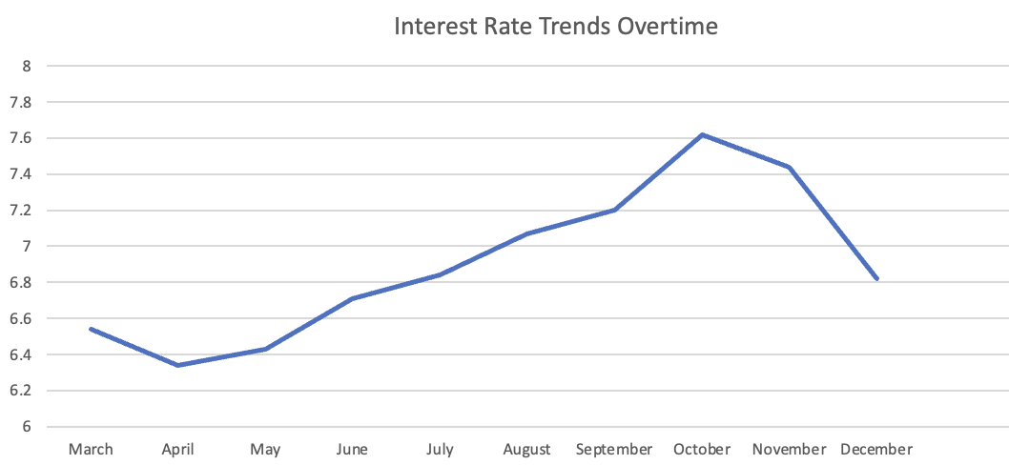
Graph 1: Interest Rate Trends Over Time

The above graph, (Interest Rate Trends Over Time) charts the path of interest rates from March 2023 to December 2023. After a gradual ascent that peaked in October, rates took a downturn, echoing the Federal Reserve’s response to inflationary pressures and the broader economic environment. This change in rates directly influences the cost of borrowing, including mortgages, and subsequently, the decisions of consumers in the housing market.

New Home Sales
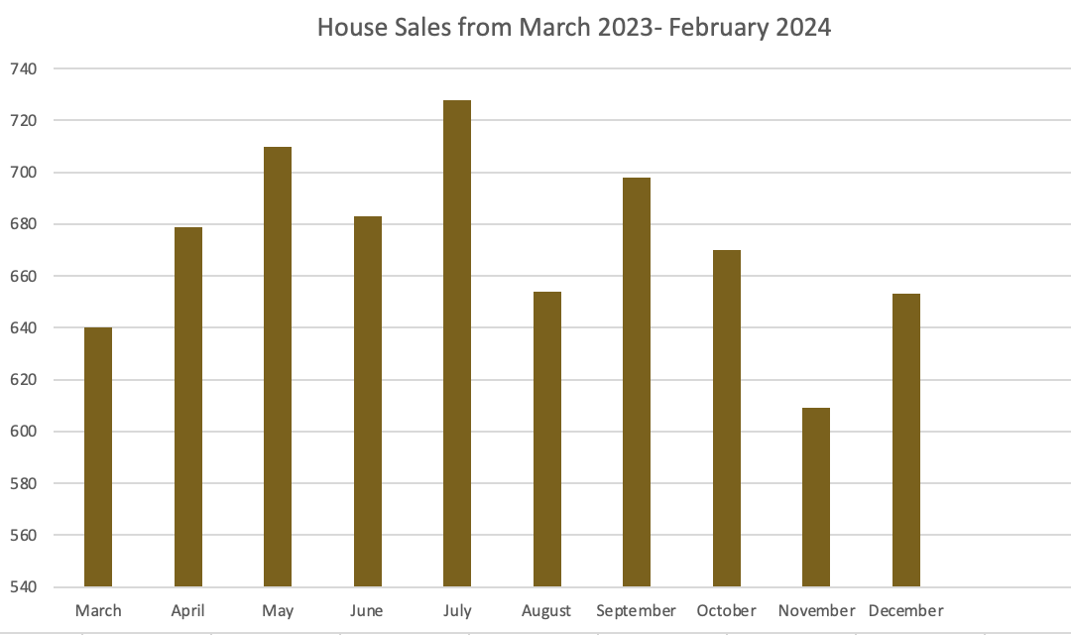
Graph 2: House Sales from March 2023 - February 2024

Despite the interest rate hikes, the housing market demonstrated a resilient spirit. As shown in the second graph (House Sales from March 2023- December 2023), new home sales experienced fluctuations but generally maintained an upward trajectory. The graph shows that the number of houses sold remained robust, even as mortgage rates climbed. This trend can be attributed to a confluence of factors including a rebounding economy, pent-up demand post-pandemic, and a persistent shortage in housing inventory which sustained buyer interest.

However, this resilience in home sales contrasts starkly with the slipping affordability of housing for the average buyer. The third graph (Affordability Index) paints a sobering picture of a market where homes become less accessible as interest rates rise. The index's dip to its nadir in September correlates with the peak in interest rates, illustrating a direct relationship between the cost of borrowing and the ability of consumers to afford new homes.
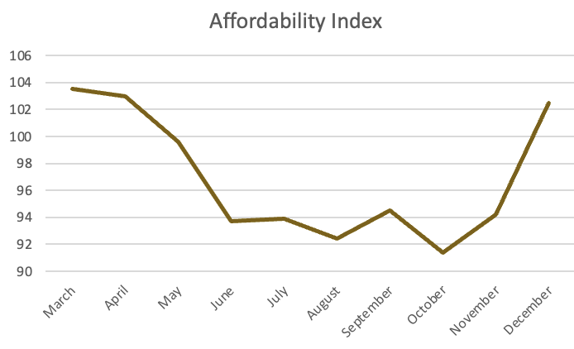
A

Graph 3: Affordability Index

Challenging Climate for Homeownership

The recent economic landscape has been challenging for potential homeowners. The sharp rise in interest rates, part of the Federal Reserve's strategy to curb inflation, has led to an uptick in mortgage rates. For many, this has translated into prohibitively high monthly payments, pushing the dream of owning a home beyond their financial reach. The decrease in affordability has also heightened the rental market's stress, as more individuals are priced out of buying, increasing the demand for rental properties.

Moreover, the impact of interest rates extends beyond immediate affordability. It also affects home equity, with current homeowners seeing a potential reduction in their property's value as higher rates deter new buyers. This scenario could limit homeowners' ability to leverage their property for financial endeavours, such as borrowing against equity or selling their homes at a profit.

The Broader Economic Impact

The impact of these economic changes spreads widely, influencing sectors like construction and home improvement, as well as overall consumer spending. As higher interest rates render new developments more costly, construction businesses might see a decline in orders, potentially dampening activity in connected industries. Likewise, homeowners may put off repairs or upgrades because of the more expensive loans or due to doubts about the potential value of their homes in an unstable market.

Adaptability and Policy Responses
While the Federal Reserve strives to strike a delicate balance between fostering economic expansion and managing inflation, the housing market stands at the forefront of their considerations. It's vital for policymakers to understand the extensive effects that fluctuations in interest rates can have and to remain flexible in the face of these changing conditions. On the flip side, those looking to buy a home need to be well-informed, considering both the present climate of interest rates and past market patterns before making their purchase.

Interest rates inherently fluctuate, which will always influence the economy. As recent developments have demonstrated, the housing market can react with unexpected strength during unpredictable times, though this is not without its impacts. Grasping these complex interactions is crucial for everyone involved, from those setting policies to those looking to purchase homes, to effectively deal with the complexities of the real estate market and to build a robust economic outlook.

References:
- "Interest Rates' Impact on Housing Market." U.S. Bank, U.S. Bancorp, March 27 2024, www.usbank.com/investing/financial-perspectives/investing-insights/interest-rates-impact-on-housing-market.html.
- "30-Year Mortgage Rates Chart." The Mortgage Reports, The Mortgage Reports, n.d., themortgagereports.com/61853/30-year-mortgage-rates-chart.
- "How to Graph Three Variables in Excel." GeeksforGeeks, n.d., www.geeksforgeeks.org/how-to-graph-three-variables-in-excel/.
- "2024 Housing Affordability Index - March 2024." National Association of Realtors, National Association of Realtors, 8 Mar. 2024, https://www.nar.realtor/research-and-statistics/housing-statistics/housing-affordability-index
- U.S. Census Bureau. "New Residential Sales." U.S. Census Bureau, March 25th 2024, www.census.gov/construction/nrs/pdf/newressales.pdf.
- "Investopedia." Investopedia, Dotdash Meredith, May 16 2023, www.investopedia.com/mortgage/mortgage-rates/housing-market/#:~:text=They%20determine%20how%20much%20consumers,rates%20generally%20do%20the%20opposite.
- Goodman, Laurie, and Michael Neal. "How Higher Mortgage Rates Have Historically Affected Home Prices." Urban Institute, 2 May 2022, www.urban.org/urban-wire/how-higher-mortgage-rates-have-historically-affected-home-prices
- "WealthBuilders Podcast: Real Estate Market Update 2023." WealthBuilders, June 1 2023, www.wealthbuilders.org/real-estate-market-update-2023-the-wealthbuilders-podcast/?gad_source=1&gclid=Cj0KCQjwk6SwBhDPARIsAJ59Gwe7_7S2n_Ws3c71qmUmAyxEeRi8H-Soz09PLsbhojQHB6Pawl5J1ikaAkc3EALw_wcB.

