**A Preliminary Study on Social Security and Implications of its Potential Failure**

The Social Security Act of 1935 cemented the creation of “social insurance” in America. It aimed to provide the elderly with retirement security, “Social insurance, as conceived by President Roosevelt, would address the permanent problem of economic security for the elderly by creating a work-related, contributory system in which workers would provide for their own future economic security through taxes paid while employed” (Historical Background and Development of Social Security). This entails employees and employers paying payroll taxes to provide income to the fund and in return are paid monthly benefits in retirement until they pass away. Currently social security encompasses two trust funds Old-Age and Survivors Insurance (OASI) and Disability Insurance (DI). There are 56 million OASI beneficiaries and 9.2 million DI beneficiaries (The 2022 OASDI Trustees Report). For Old-Age beneficiaries, benefits are calculated by taking the beneficiaries Average Indexed Monthly Earnings (AIME) by taking the highest-earning 35 years of work and dividing that sum by 420 months. Then the following formula is applied to get the Primary Insurance Amount (PIA):

* 90% of the first $996 of AIME
* 32% of the amount between $996 and $6,002 of AIME
* 15% of the amount above $6,002 of AIME

The sum of these three amounts is the beneficiary’s monthly PIA. Additionally, beneficiaries have the option of receiving benefits before their Full Retirement Age which reduces their PIA by:

* 0.55% reduction for each month, up to 36 months
* 0.42% reduction for each month, exceeding 36 months to a maximum of 60 months

Finally, benefits are adjusted every year with a cost-of-living-adjustment (COLA) based on the Consumer Price Index for Urban Wage Earners and Clerical Workers (CPI-W). Focusing on currently retired workers, the average monthly benefit in 2021 for retired workers was $1,658 with a total of 47.3 million retired worker beneficiaries. This is a total of about $0.94 trillion benefits paid to retirees for the year 2021(The 2022 OASDI Trustees Report). These benefits are paid from a combination of income from payroll taxes, taxes on benefits, and from interest on assets in the trust fund. The assets in the trust fund are invested in special issue U.S. Treasury securities that are virtually “risk-free”. This program has allowed countless millions of Americans to be able to retire and has been a great service to Americans for decades, unfortunately it is a temporary solution to a permanent problem.

The construction of Social Security is not holding up against the test of time. Its integrity has been compromised by the following four factors. First, dramatic demographic shifts in the U.S. population have significantly exaggerated pressure on the system. Life expectancy has increased by 10.8% from 1960 to about 77.3 years in 2020 (Appendix 1) (CPI-W, St Louis Fed). Moreover, fertility rate has decreased by 55% from 1960 to about 1.64 births per woman in 2020(Fertility Rate, St Louis Fed)(Appendix 4). This means there are less people paying for social security at any given time and those receiving benefits receive them for much longer. Second, the interest earned on the funds’ assets are tied to interest rates. The average federal funds rate the past 20 years (Jan 2003-Jan 2023) has been an unbelievably low 1.31% (St. Louis Fed) (Appendix 6). Third, COLA adjustments are unpredictable and tied to inflation. In the same twenty year time period the average CPI-W was 2.47% (St Louis Fed)(Appendix 7). This means the real return between the interest on the Social Security trust fund assets and its COLA is -1.16% (this assumes the Federal Fund rate is equivalent to the yield of the bonds and represents the average real return over the 20 year period). Fourth, the political environment and legislation around social security is unproductive. There have not been any significant overhauls in the fundamental system of social security since its inception (Social Security History). Retirement is a hard subject to talk about and any changes can’t be agreed on or glossed over entirely. Social Security is a system created almost a hundred years ago that has not been updated and is not robust enough to function in today’s world. In summary, the system of Social Security is an aging system that has started to fail from a variety of factors, and nothing is being done about it.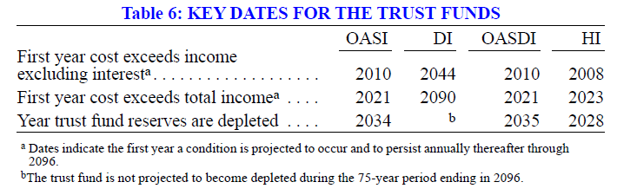

*Figure : Key Dates for Social Security Trust Funds*

*Source: Status of the Social Security and Medicare Programs*

All of these problems have culminated to where it is today. Just two years ago, in 2021, the costs of social security exceeded its total income from taxes for the first time ever (Status of the Social Security and Medicare Programs). This is expected to happen every year until the fund becomes insolvent. It is projected that that the OASI Trust Fund assets will be fully depleted and be insolvent by 2034. Once these assets are depleted, any benefits would be paid directly from the taxes collected, which are projected to be able to cover 77% of obligations until 2096 (Status of the Social Security and Medicare Programs). Unfortunately, the U.S. government must cover 100% of its obligations and leaves them with some undesirable choices, “(1) revenue would have to be increased by an amount equivalent to an immediate and permanent payroll tax rate increase of 3.24 percentage points to 15.64 percent; (2) scheduled benefits would have to be reduced by an amount equivalent to an immediate and permanent reduction of 20.3 percent applied to all current and future beneficiaries through 2096, or 24.1 percent if the reductions were applied only to those who become initially eligible for benefits in 2022 or later; or (3) some combination of these approaches would have to be adopted. If actions are deferred for several years, the changes necessary to maintain Social Security solvency through 2096 become concentrated on fewer years and fewer generations” (The 2022 OASDI Trustees Report).

A permanent payroll tax rate increase of 3.24% to 15.64% represents about a 26% increase in the payroll tax rate. This tax rate would have wide consequences across the entire U.S. economy. Taking a conceptual approach to this change. First, a payroll tax is split between the employee and employer. This would make each entities payroll tax rate 7.82%. Thus, it reduces incentives of working for both producers and consumers. Second, this would reduce how much people work and how much producers hire. Overall, we can assume people work less hours and their overall consumption and income decreases. Thus, with a decrease in overall income people have less money to invest back into the economy. The combination of less investment and consumption would decrease economic output and therefore economic growth. 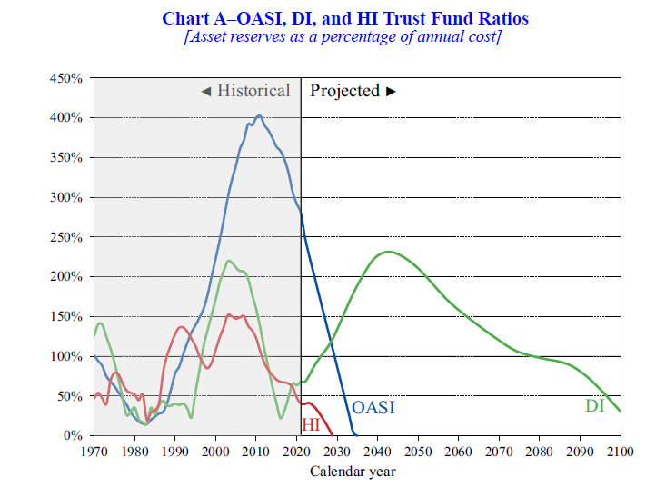

*Figure : Trust Fund Rations*

*Source: Status of the Social Security and Medicare Programs*

On the other hand, a 20.3% reduction in benefits would be detrimental to millions of Americans. According to the Economic Well-Being of U.S. Households Survey in 2021, in the last 12-month Social Security accounted for a source of income for 92% of retirees. This is accentuated by Dushi and Trenkamp’s findings that found Social Security as a proportion of family income (Dushi and Trenkamp, 2021):

* 50% or more of income (40% of families)
* 75% or more of income (21% of families)
* 90% or more of income (14% of families)

Additionally, the Poverty in the United States: 2021 report by the U.S. Census states that social security prevents 26.3 million from being in poverty and 15 million of those includes people 65 years old and older (Poverty in the United States 2021)(Appendix 7). Finally, 67% of workers have less than $250,000 saved for retirement (Retirement Confidence Survey 2022) (Appendix 10). This shows that the impact from a change in benefits could be catastrophic for a majority of the retired population. With social security being a critical source of income post-retirement, proposing a 20.3 reduction would never see support. Overall, both proposals would negatively impact millions and might not fix the pressures on the system as these trends progress.

These two proposals are not optimal, but is there any good solution? As highlighted before, most Americans don’t save for retirement. It is too easy to over rely on social security and not worry about coming up with one’s own retirement plan. A potential solution is to foster the idea of saving for retirement, as there might be no other alternative. It requires a better understanding of financial behaviors, an outspread of financial literacy, and accessibility to saving and investment tools. 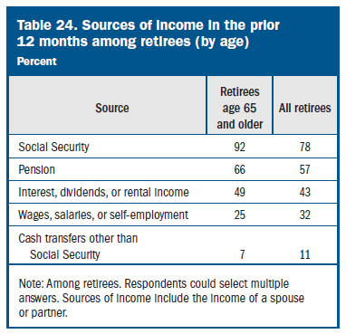

Retirement isn’t a fundamental human right, it is a byproduct of a prosperous and concordant society. It is a privilege from careful planning and foresight. Understanding behavior and attitudes towards money and retirement are a critical issue in solving this problem we all face. This issue cannot continue to be ignored as the retirement time bomb is ticking.

*Figure 3: Source of Income in Retirement*

*Source: Economic Well-Being of U.S. Households Survey in 2021*

**Appendix:**

Appendix 1: Life Expectancy

*Source: St. Louis Federal Reserve*

Appendix 2: Age Group Projections

Appendix 4: Fertility Rate in the U.S.

*Source: St. Louis Federal Reserve*

Appendix 6: Federal Fund Rate (2003-2023)

*Source: St. Louis Federal Reserve*

Appendix 7: CPI-W (2003-2023)

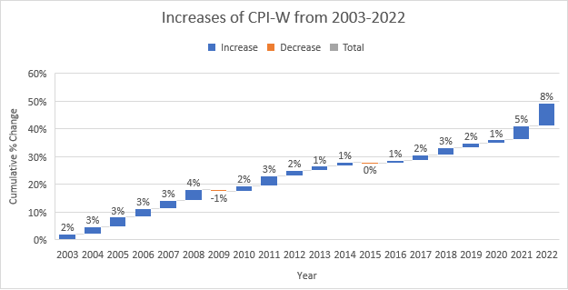

*Source: St. Louis Federal Reserve*

Appendix 8: Change in Number of People in Poverty

**Bibliography:**

*Historical Background And Development Of Social Security*. Social Security History. (n.d.). Retrieved March 31, 2023, from https://www.ssa.gov/history/briefhistory3.html

The 2022 OASDI Trustees Report. (n.d.). Retrieved March 31, 2023, from https://www.ssa.gov/OACT/tr/2022/#:~:text=The%202022%20OASDI%20Trustees%20Report%2C%20officially%20called%20%22The%202022%20Annual,status%20of%20the%20trust%20funds.

*Consumer price index for all urban consumers: All items in U.S. city average*. FRED. (2023, March 14). Retrieved March 31, 2023, from https://fred.stlouisfed.org/series/CPIAUCSL

*Fertility Rate, total for the United States*. FRED. (2022, May 3). Retrieved March 30, 2023, from https://fred.stlouisfed.org/series/SPDYNTFRTINUSA

*Status of the Social Security and Medicare programs*. (n.d.). Retrieved March 31, 2023, from https://www.ssa.gov/oact/TRSUM/tr22summary.pdf

*Report on the economic well-being of U.S. households in 2021 - May 2022*. Board of Governors of the Federal Reserve System. (n.d.). Retrieved March 31, 2023, from https://www.federalreserve.gov/publications/2022-economic-well-being-of-us-households-in-2021-executive-summary.htm

Dushi, Irena and Brad Trenkamp, 2021. *“Improving the Measurement of Retirement Income in the Aged Population”.* Washington, DC: Social Security Administration, Office of Research, Evaluation, and Statistics. ORES Working Paper No. 116. <https://www.ssa.gov/policy/docs/workingpapers/wp116.html>

*Retirement confidence survey*. EBRI. (n.d.). Retrieved March 31, 2023, from https://www.ebri.org/retirement/retirement-confidence-survey

Social Security History. (n.d.). Retrieved March 31, 2023, from https://www.ssa.gov/history/reports/crsleghist2.html

Creamer, J. (2022, September 13). *Poverty in the United States: 2021*. Census.gov. Retrieved March 31, 2023, from https://www.census.gov/library/publications/2022/demo/p60-277.html