**Universal Basic Income in the United States:**

**Exploring the Potential of Basic Income to Remedy Job Loss and Racial Inequity**

Arizona State University

March 31, 2023

The preamble to the United States Constitution calls for the Federal Government’s promotion of general welfare. In other words, one of its primary responsibilities is to ensure the well-being of its constituents. In the 21st century, this can be interpreted as justification for a substantial welfare system that provides a social safety net. Recently, proposals for a Universal Basic Income (UBI) have been floated as the potential basis for such a system. Despite programs such as Social Security, CHIP, SNAP, and Medicaid providing some assistance, the prevalence of poverty and unemployment calls for welfare reform. In order to address rising job displacement as well as the racial wealth gap, it is imperative that the United States implement a Universal Basic Income to serve as both an economic and social safety net.

The most important indicators of the need for UBI in the US are the stagnation of wages and looming job displacement. Since the 1960s, the growth rate of job creation has decreased every decade (Burns & Schneider, 2020). The percentage of US GDP going to wages has fallen from approximately 65% in 1970 to 60% in 2019 (“Share of labour,” 2021). One of the more consequential root causes of this phenomenon is the rise of automation. According to Oxford Economics, the US has already lost over 250,000 jobs to automation, representing about 2% of the workforce. Although that may not seem significant, the report predicts over 1.5 million will be lost by 2030 (Lardieri, 2019). The result of this is a significant drop in the employment to population ratio: from 64.4% in January 1999 to 60.2% in February 2023 (“Employment-population ratio,” 2023). The decline in working Americans and shrinking job market reveals a need for a stronger social safety net. A stable income floor would allow for citizens to either save extra money while working day jobs or have a passive source of income while earning college degrees in order to work more skilled jobs. The adoption of UBI satisfies this need.

Although such a policy has never been implemented in a setting on the scale of the United States, exploring past experiments and studies can help predict possible outcomes. A report published by Stanford University’s Basic Income Lab analyzes sixteen studies and experiments focusing on a range of topics surrounding UBI and its effects in the context of low, middle, and high-income countries. Findings were “generally positive that UBI type programs alleviate poverty and improve health and education outcomes and that the effects on labor market participation are minimal.” Perhaps surprisingly, “some studies [reported] an increase in labor market participation” (Hasdell, 2020, pp. 16-18). A 2016 report by Stewart Lansley and Howard Reed that examined similar experiments found…positive benefits for nutrition, health, education, housing and infrastructure, and economic activity (12). Recently, The Stockton Economic Empowerment Demonstration (SEED) randomly selected 125 residents (under a certain income threshold) in Stockton, California. Participants were given $500/month for two years. Their demographics are detailed in Figure 1 below.

**Figure 1**

*Demographic Data of SEED Treatment and Control Groups*

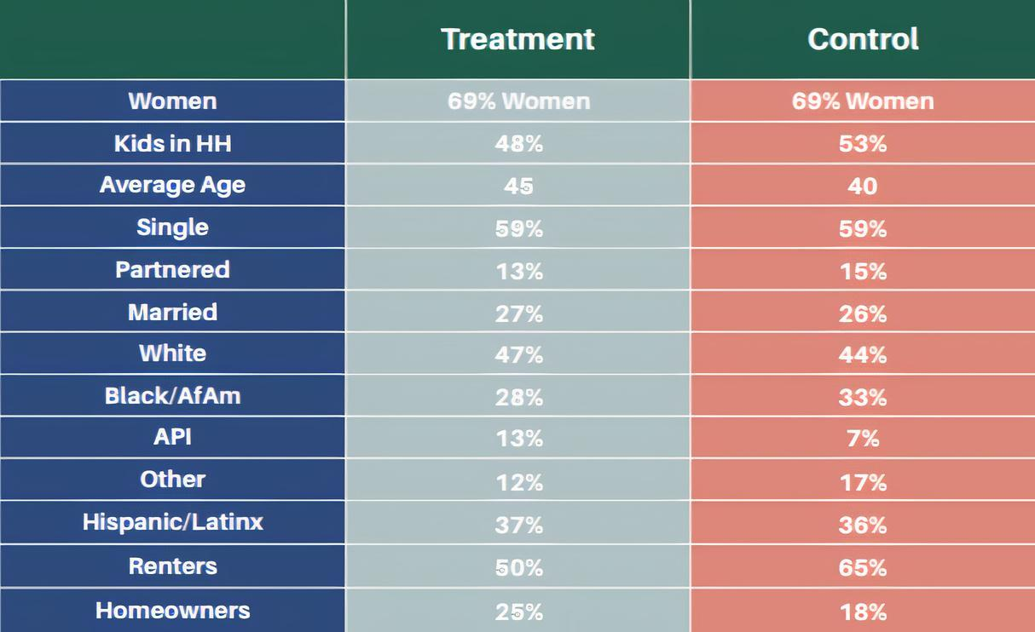

*Note.* From *Preliminary Analysis: SEED’s First Year* (p. 5), by S. West, A. Castro Baker, S. Samra, & E. Coltrera, 2021, Stockton Economic Empowerment Demonstration.

After one year, “the largest spending category each month was food, followed by sales/merchandise.” Contrary to the idea that some recipients of UBI would spend it on harmful substances, “[l]ess than 1% of tracked purchases were for tobacco/alcohol.” Additionally, the group “demonstrated [1.5x less] month-over-month income volatility than those in the control group.” Perhaps most encouraging, the share of participants employed full-time increased from 28% to 40% (West et al., 2021, pp. 12-21). The New Jersey Graduated Work Incentive Experiment also tested cash transfers to families between 1968 and 1971. Once again, the impacts on recipients were largely beneficial. Even high school graduation rates rose by 30%. Another well-known system replicating UBI is the Alaska Permanent Fund; since 1982, Alaskan families have received between $1000 and $2000 per person per year. This has reduced poverty by 25%. Alaska also has the lowest income inequality in the country (Yang, 2019, 176-177).

Opponents to UBI claim that unconditional cash payments to citizens would result in recipients being disincentivized to work. Researchers conducted a study testing this theory in which various cash transfer systems were inspected. UBI programs were found to not have “a significant effect...on employment or hours of work in any of the seven programs” (Banerjee et al., 2017, pp.168-174). Another counterargument is that implementation of UBI would be too expensive for the federal government. Estimates say that UBI would cost the government between $2.5 and $4 trillion dollars per year (Ayres & Jeroen van den Bergh, 2021). While this may sound pricey, the Biden administration’s 2021 American Rescue Plan cost $1.9 trillion dollars (Haagensten, 2021). After the 2008 Financial Crash, bank bailouts totaled $500 billion dollars (Harbbert, 2019). An important point to note is that “UBI would reduce the need for the EITC, CTC, TANF, SNAP, and perhaps disability and unemployment insurance” (Hoynes & Rothstein, 2019, p. 946). Finally, a misconception is that direct payments to recipients will result in rapid inflation. Evidence from cash transfer systems tested in Lebanon found that “grants do not cause inflation” (Masterson, 2016). In Sub-Saharan Africa, “evidence across the countries studied...clearly shows that communities receiving cash transfers [were] not subject to price inflation” (Handa et al., 2018, p. 286). While these economies cannot be evenly compared to the United States, because they are more volatile and susceptible to inflation, one can reasonably infer that UBI is unlikely to cause inflation in the US economy.

Another concern UBI has the potential to solve is racial inequity. As of 2016, the net worth of the average White household ($171,000) is almost ten times as much as the average Black household’s ($17,150). Homeownership, an important indicator of economic well-being, tells a similar story. While 72% of White families owned their home in 2016, just 44% of Black ones did so. Perhaps most telling, the median White worker made 26% more than the median Black worker in 2021. Over time, these disparities have not only persisted but increased. Estimates say that the ratio of White to Black household wealth was higher in 2020 than in 2000 (McIntosh et al., 2020). Looking to the future, projections state that median Black household wealth will decline to zero in 2053 (Collins et al., 2021). If left unsolved, the racial wealth gap will continue to devastate Black communities while costing the federal government up to $1.3 trillion (Nowel et al., 2019). Needless to say, a wealth-building welfare program can be the solution to this problem. UBI can offer an invaluable disposable income that countless African Americans have lacked for centuries.

Firstly, it is important to note that it is unrealistic to expect UBI to close the racial wealth gap solely through cash transfers. Rather, it can act as a supplemental income that enables recipients to generate wealth for themselves. African Americans disproportionately live paycheck to paycheck (Leonhardt, 2021). UBI beneficiaries could save for emergency expenses or finance higher education; these are avenues that can lead to wealth creation. It could even assist one in saving for a down payment on a home, opening the door for homeownership. The ubiquity of single-parent households in one more difficulty for the Black community. Children in these families face a major disadvantage. Approximately half of single-parent families live in poverty compared with one tenth of two-parent households (*Why Single Parenthood*, n.d., p. 23). In particular, this affects Black children the most. In 2019, a staggering 64% of African American children lived in single-parent households, compared to 24% of White children (*Children in single-parent*, 2019). UBI would theoretically improve the wealth status of single parents. Additionally, supplemental income may lower the rates of single-parenthood in the first place, as families in more stable financial conditions could be more incentivized to stay together.

To continue to act in the best interests of the people, the United States must institute a Universal Basic Income in order to create a stable income floor for individuals. It should be noted that a large expense such as this one is an investment in the country and its citizens. UBI would introduce significantly greater opportunities for recipients to spend and thus help stimulate the economy. More importantly, it creates opportunities for individual wealth creation through investment, home ownership, higher education, and many other values. As automation continues to cause rapid job displacement in the country and the racial wealth gap further widens, it should be considered the duty of the government to combat this through a robust welfare system that establishes financial stability as a norm, rather than a privilege. Based on its comprehensiveness and demonstrated experimental benefits, a Universal Basic Income is an ideal choice to implement in the United States.

References

Asante-Muhammad, D., Collins, C., Hoxie, J., & Nieves, E. (2017). The road to zero wealth: How the racial wealth divide is hollowing out America's middle class.

Ayres, R. U., & van den Bergh, J. (2021, January 19). *Why Universal Basic Income Should Be President Biden’s Top Priority* . INSEAD Knowledge. Retrieved March 30, 2023, from https://knowledge.insead.edu/blog/insead-blog/why-universal-basic-income-should-be-president-bidens-top-priority-15926

Banerjee, A. V., Hanna, R., Kreindler, G. E., & Olken, B. A. (2017). Debunking the stereotype of the lazy welfare recipient: Evidence from cash transfer programs. *The World Bank Research Observer*, *32*(2), 155–184. <https://doi.org/10.1093/wbro/lkx002>

Burns, D., & Schneider, H. (2020, January 10). *U.S. employment in the 2010s in five charts*. Reuters. Retrieved March 30, 2023, from <https://www.reuters.com/article/us-usa-economy-jobs-graphic-idUSKBN1Z92AK>

Center, K. C. D. (2019). Children in single-parent families by race in the United States.

*Employment-population ratio*. FRED. (2023, March 10). Retrieved March 30, 2023, from https://fred.stlouisfed.org/series/EMRATIO.

Haagensen, E. (2022, December 19). *American Rescue Plan*. Investopedia. Retrieved March 30, 2023, from <https://www.investopedia.com/american-rescue-plan-definition-5095694>

Handa, S., Daidone, S., Peterman, A., Davis, B., Pereira, A., Palermo, T., & Yablonski, J. (2018). Myth-busting? Confronting six common perceptions about unconditional cash transfers as a poverty reduction strategy in Africa. *The World Bank Research Observer*, *33*(2), 259-298.

Harbert, T. (2019, February 21). *Here's how much the 2008 bailouts really cost*. MIT Sloan. Retrieved March 30, 2023, from https://mitsloan.mit.edu/ideas-made-to-matter/heres-how-much-2008-bailouts-really-cost

Hasdell, R. (2020). What We Know About Universal Basic Income. *The Stanford Basic Income Lab*. Retrieved March 30, 2023, from <https://basicincome.stanford.edu/uploads/Umbrella%20Review%20BI_final.pdf>

Hoynes, H., & Rothstein, J. (2019). Universal basic income in the United States and advanced countries. *Annual Review of Economics*, *11*, 929-958.

Lardieri, A. (2019, June 26). *Report: Robots will replace 20 million manufacturing jobs by 2030*. U.S. News and World Report. Retrieved March 31, 2023, from <https://www.usnews.com/news/economy/articles/2019-06-26/report-robots-will-replace-20-million-manufacturing-jobs-by-2030>

Leonhardt, M. (2021, January 28). *Black and Hispanic Americans often have lower credit scores-here's why they're hit harder*. CNBC. Retrieved March 31, 2023, from https://www.cnbc.com/2021/01/28/black-and-hispanic-americans-often-have-lower-credit-scores.html

Masterson, D. (2016). Giving better: Lessons from Cash Grants for Syrian Refugees in Lebanon. *Refugee Research and Policy in the Arab World*.

McIntosh, K., Moss, E., Nunn, R., & Shambaugh, J. (2020). Examining the Black-white wealth gap. *Washington DC: Brooking Institutes*.

Noel, N., Pinder, D., Stewart, S., & Wright, J. (2019). The economic impact of closing the racial wealth gap. *McKinsey & Company*.

Reed, H., & Lansley, S. (2016). Universal Basic Income: An idea whose time has come? *Compass*. Retrieved March 30, 2023, from https://www.compassonline.org.uk/publications/universal-basic-income-an-idea-whose-time-has-come/

*Share of labour compensation in GDP at current national prices for United States*. FRED. (2021, January 21). Retrieved March 30, 2023, from https://fred.stlouisfed.org/series/LABSHPUSA156NRUG

West, S., Castro Baker, A., Samra, S., & Coltrera, E. (2021). (rep.). *Preliminary Analysis: SEED’s First Year*. Stockton Economic Empowerment Demonstration. Retrieved March 30, 2023, from https://socialprotection.org/discover/publications/preliminary-analysis-seed%E2%80%99s-first-year

Wisconsin Family Impact Seminars. (n.d.). *Why single parenthood affects children (PDF)*. Purdue University. Retrieved March 30, 2023, from https://www.purdue.edu/hhs/hdfs/fii/wp-content/uploads/2015/07/s_wifis02c04.pdf

Yang, A. (2019). *The War on Normal People: The Truth About America's Disappearing Jobs and Why Universal Basic Income Is Our Future*. HACHETTE Books.