Economics Review Essay
Bank Runs & Bad Times- the Impact of Uninformed Optimism in Low Interest Rate Environments
Failing banks, bank runs, industry consolidation, Bitcoin to the moon, yield curve inversion, inflation- what a time to be alive in financial markets. On March 10th, 2023, Silicon Valley Bank- the 16th largest bank in the United States- was shut down by the California Department of Financial Protection and Innovation leading to a series of events reminiscent of the Great Financial Crisis of 2008. During the week, VIX, the Chicago Board Options Exchange volatility index jumped 37% during the week, Bitcoin rose 34% due to distrust of banks, other regional bank stocks crashed due to SVB failure, and bond yields crashed with uncertainty of Federal Reserve action.
SVB Wrong Place Wrong Time
The Silicon Valley Bank failure was the largest bank failure since 2008. What went wrong? SVB’s bond portfolio is to blame. In 2021, SVB saw deposits rise from $62 billion to $124 billion, a 100% increase (Chappatta, 2023). These deposits came in the form of large venture capital funds, large corporations, and the hottest startups. SVB was the bank for technology and innovation, nothing could ever go wrong. With the large influx of deposits, SVB had more cash on hand than they could possibly allocate, so they made a logical bet on long term government bonds (Nangle, 2023). Reality set in quickly soon after with the Fed Raising interest rates to tame rampant inflation at 9%. The rising interest rates crushed underlying bond value (Tepper, 2023) resulting in a $15BN unrealized loss, which became material at the beginning of March 2023. What was once viewed as a safe investment was now a huge hole across banks. This led large organizations to pull funds quickly from the bank resulting in a need for liquidity that did not exist. Bank runs, however, prove to be a piece of the uninformed optimism from 2020-2021. There are no happy endings, just depends on where you end the story.
What Formed the Uninformed Optimism
In early March 2020, equities worldwide crashed comparable to the worst financial crises such as the Great Depression 1929-1939, the recession 1980-1983, and the Global Financial Crisis of 2007-2009. This, however, was different. The world wasn’t suffering from inflation, fundamental issues with the financial system, or currency instability. The crash was simply attributed to the fact that people thought the world was ending. The crash ultimately led to government intervention and quantitative easing from the Fed in the form of a zero interest rate environment, large buy back of government securities, and stimulus (Long, 2020). This grew bullish sentiment and led to one of the greatest stock rallies of all time driven by popularization of retail investing, low interest rates, and artificially high tolerance for risk. High growth sectors such as technology benefited heavily from low cost of capital, the need for new technology, and the excitement around innovation. M&A, Private Equity & Venture Capital saw its greatest activity of all time (Bain & Company, 2022). Disposable income grew due to stimulus leading to drastic increases in prices in the housing market and the great migration to sunbelt states (Scopelliti, 2021). Everyone thought these days would last forever, and they seemingly did, quelling all signs of correction until the first rate hikes of 2022.
Consequences of Uninformed Optimism
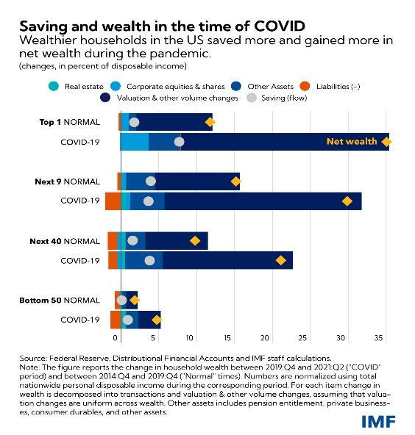
Loose economic policy was undoubtedly necessary given the circumstances surrounding the COVID-19 pandemic, but did loose economic policy solve short term issues without long term effects? We can look at this debate from both the investor and consumer perspective. As of 2023, the market is performing well considering a hawkish Fed and rising interest rates. Private capital, however, is down significantly. Venture Capital investment is down ~60% YoY (Bannon, 2022) while M&A activity is also down significantly from its 2021 highs (Morgan Stanley, 2023). The growth seen in 2020-2021 could be seen as somewhat superficial and optimistic due to low interest rates and market optimism surrounding growth. From a valuation perspective, low interest rate environments provide greater cash flows and higher valuations than times of higher interest rates due to a more favorable discount premium. This subsequently drives valuations across the board due to higher earnings or revenue multiples and with growth in mind, investors were happy to pay a premium. With essentially free capital, investors looked to deploy capital in any which way possible. Now in times of economic tightening, business fundamentals have become of the utmost importance and companies now must face the reality of financial obligations such as debt. With greater costs of capital due to rising interest rates, businesses private and public will be tested through quality earnings and ability to meet financial obligations. Valuations have been significantly struck down with large consolidation in high growth industries such as technology, semiconductors, and EVs. From an investor perspective, the stimulus and loose economic policy in the short term helped small businesses stay afloat and presented high growth opportunities for companies across the board. Although we have not seen the true long-term negative effects of loose economic policy, it has become apparent that companies that have not prepared well for the choppy macro-environment face great challenges ahead. This narrative has already begun to play itself out seen through large layoffs in the technology industry and increasingly cautious capital markets. The correction has already begun to shatter the uninformed optimism of investors and has shifted investment to value companies.
From the consumer perspective, the short-term effects of loose economic policy were essential due to the slow economic conditions. However, post-government intervention the consumer benefited heavily. Illustrated by percentage of disposable income, Americans saw increases in wealth across the board due with richer Americans benefiting more from positioning in equities.
(IMF, 2021)
The personal wealth increase led to a large uptick in the housing market and new work from home trends saw Americans migrating away from cities into more rural areas. The investor story parallels the one of the consumer. The opportunity and availability of capital for spending became greater, however, the consumer would also be tested by tough times ahead seen through their ability to save. The one key difference in the investor and consumer story is inflation. Although Americans saw increases in personal wealth, life got more expensive. Groceries, gas, cars, and housing prices grew, and the tightening macro-environment serves to be a potential challenge to the consumer to finance their lifestyles. In conclusion, the loose economic policy was able to solve the short-term issues surrounding the everyday American’s ability to live, but lead to high inflation. The long-term effects are still playing themselves out today, but the Fed’s reaction seen through higher interest rates will test middle-class America on their spending and savings habits. Was the consumer responsible in their spending or will we see a large increase in defaults on loans for large expenses such as cars and homes similar to that of ’08?
Closing Thoughts
We began this article discussing the recent hot stories surrounding bank runs and the eerie parallels to other recessions. Is this time any different? Overall, the Fed has been particularly cautious in its actions to tame inflation and to strengthen the fundamentals of the economy. These times ahead are where both the market and consumer will be tested and we will soon learn if the optimism is a reality or mirage. In good economic times, everyone wins, but in the bad times some lose more than others. The uninformed optimist believes that the good times last forever, but if history can teach us anything, with all market cycles comes a test and those who pass move into the new reality while those who don’t become extinct.

References
2023 M&A Outlook: 4 trends to watch. Morgan Stanley. (n.d.). Retrieved April 1, 2023, from https://www.morganstanley.com/ideas/mergers-and-acquisitions-outlook-2023-trends
Bannon, M. T. (2022, December 21). 12 predictions for venture capital in 2023. Forbes. Retrieved April 1, 2023, from https://www.forbes.com/sites/marenbannon/2022/12/20/12-predictions-for-venture-capital-in-2023/?sh=53a83b6a515b
Chappatta, B., & Bloomberg. (2023, March 12). How silicon valley bank's fate was sealed at the moment of its Triumph just a few years ago. Fortune. Retrieved April 1, 2023, from https://fortune.com/2023/03/10/how-silicon-valley-banks-fate-sealed-2021-venture-capital-bonds-interest-rates/
IMF. (2021, November 9). The unequal Covid saving and Wealth Surge. IMF. Retrieved April 1, 2023, from https://www.imf.org/en/Blogs/Articles/2021/11/09/the-unequal-covid-saving-and-wealth-surge
Long, H. (2020, March 16). Federal Reserve slashes interest rates to zero as part of wide-ranging emergency intervention. The Washington Post. Retrieved April 1, 2023, from https://www.washingtonpost.com/business/2020/03/15/federal-reserve-slashes-interest-rates-zero-part-wide-ranging-emergency-intervention/
MacArthur, H. (2022, March 9). The 2022 global private equity report: Market overview. Bain & Company. Retrieved April 1, 2023, from https://www.bain.com/insights/the-2022-global-private-equity-report-market-overview-podcast/
Nangle, T. (2023, March 20). Bonds were seen as a safe haven – but they are central to this bank crisis | Toby Nangle. The Guardian. Retrieved April 1, 2023, from https://www.theguardian.com/business/2023/mar/20/bonds-bank-crisis-silicon-valley-bank-credit-suisse-interest-rates
Scopelliti, D. (n.d.). Covid-19 causes a spike in spending on durable goods : Monthly Labor Review. U.S. Bureau of Labor Statistics. Retrieved April 1, 2023, from https://www.bls.gov/opub/mlr/2021/beyond-bls/covid-19-causes-a-spike-in-spending-on-durable-goods.htm#:~:text=The%20authors%20cite%20data%20from,billion%2C%20resulted%20from%20fiscal%20stimulus.
Tepper, T. (2023, March 22). Federal Funds Rate history 1990 to 2023. Forbes. Retrieved April 1, 2023, from https://www.forbes.com/advisor/investing/fed-funds-rate-history/

