The Covid-19 Pandemic and its Lasting Effects on the Video Game Industry

The video game industry is in many ways similar to the other entertainment industries: people gain similar amusement and enjoyment from playing games as they do from binging television or catching a new film at the movie theater. However, the video game industry has several unique aspects that other entertainment industries do not, ultimately making its market performance highly susceptible to dynamic behavior. For example, video game developers must take into consideration whether the demand will be higher for a single-player or multiplayer game, a puzzle game or a platformer, or a mobile game versus a console game. In addition, entertainment industries face demand issues in times of general or individual economic disruption, as they are ultimately unnecessary and one of the first expenses consumers look to cut out of their budget to save money. One of these times of general disruption, the Covid-19 pandemic, caused an unforeseen economic boom within the gaming industry and the effects are still being felt within the video game market today.

Perhaps the most memorable impact of the Covid-19 pandemic is the extensive amount of time that everyone spent at home. Not only did people have more time to allot toward entertainment in general, but specifically the pandemic resulted in consumers being driven to forms of entertainment that were consumable from the safety of their homes. For example, the streaming service industry reached over one billion collective memberships during the heat of the pandemic (Watson, 2021). At the same time, forms of entertainment that required consumers to put themselves at risk of contracting the new illness suffered severe market losses; on the contrary, global box-office revenues fell by 30 billion dollars during the pandemic (Watson, 2021). Similar to streaming services, the video game industry boomed as a result of the increase in time that people spent in their homes.

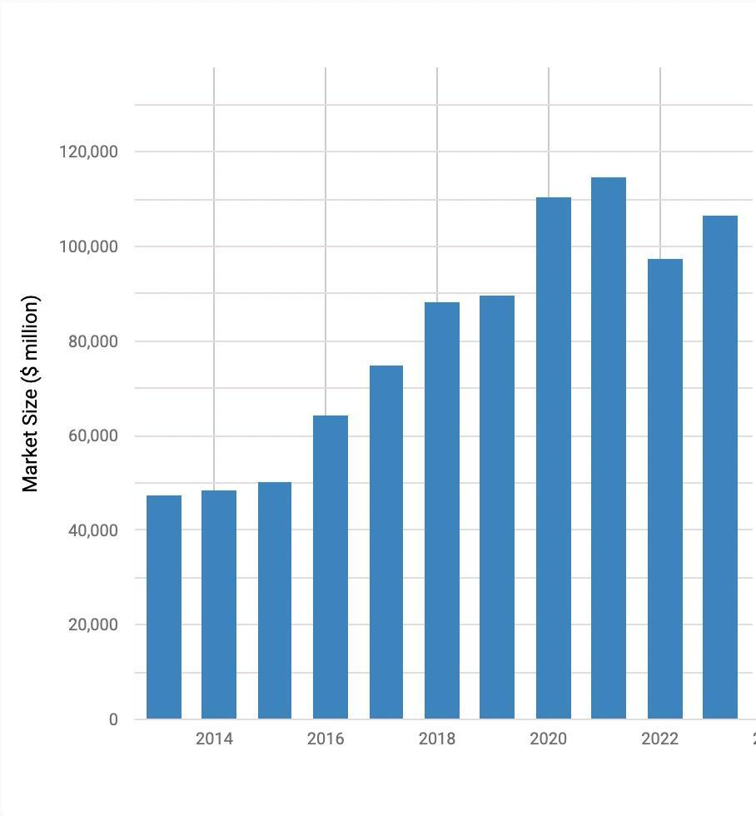

Source: IBISWorld January 2023 Report of Video Game Market Revenue

IBISWorld’s January 2023 report on the video game industry’s revenue over the past ten years clearly displays the industry-wide boom of the over $20,000 million size increase that the video game market underwent as a result of the increased demand for entertainment within the pandemic.

As consumers demanded more video games during the pandemic, game developers and manufacturers scrambled to produce the equilibrium quantity that the market demanded. Because of the high demand for consoles during the pandemic, there was an industry-wide semiconductor chip shortage that stunted the production of not just Sony’s PlayStation 5, but also similar substitutes such as the Xbox Series X and the Nintendo Switch. This not only made consoles very hard to come by for consumers, but the prices of the few available consoles skyrocketed; *Reuters* reported that the PlayStation 5 consoles were being marked up by resellers from their retail price of $500 to anywhere around $900 (Nussey, 2020). Unfortunately, the effects of the chip shortage are still being felt in the current video game market. Sony claims that the PlayStation 5 shortage is over as of December 2022, but NPR reports that Sony’s consoles, and its similar substitutes, are moderately hard to come by and “still out of stock at BestBuy and most GameStop stores” (Fernandez, 2023). This ongoing shortage displays the severe impact that the Covid-19 pandemic left on the supply chain and the particularly significant impact that it left on the video game console industry.

However, advancements in technology and a rehealing world economy have allowed for the production of video game consoles to stabilize. As semiconductor chips slowly start to become easier for console producers to obtain for their consoles, gaming companies are finally able to increase production to approach the equilibrium quantity that the market desires. Sony Interactive Entertainment CEO Jim Ryan stated that “[Sony is] planning for heavy further increases in console production, taking us to production levels that we've never achieved before” (Nussey 2022). Sony advanced their production by expanding its factories and enhancing shipment efficiency as the pandemic subsidies worldwide, specifically increasing production capabilities in Shanghai, where much of its production takes place, as the country begins to lift pandemic safety protocols (Winslow, 2022).

Unsurprisingly, as demand for consoles rose consistently during the pandemic, demand rose similarly for complimentary video games and gaming accessories that people utilize with their consoles and has continuously risen as the pandemic has subsided.

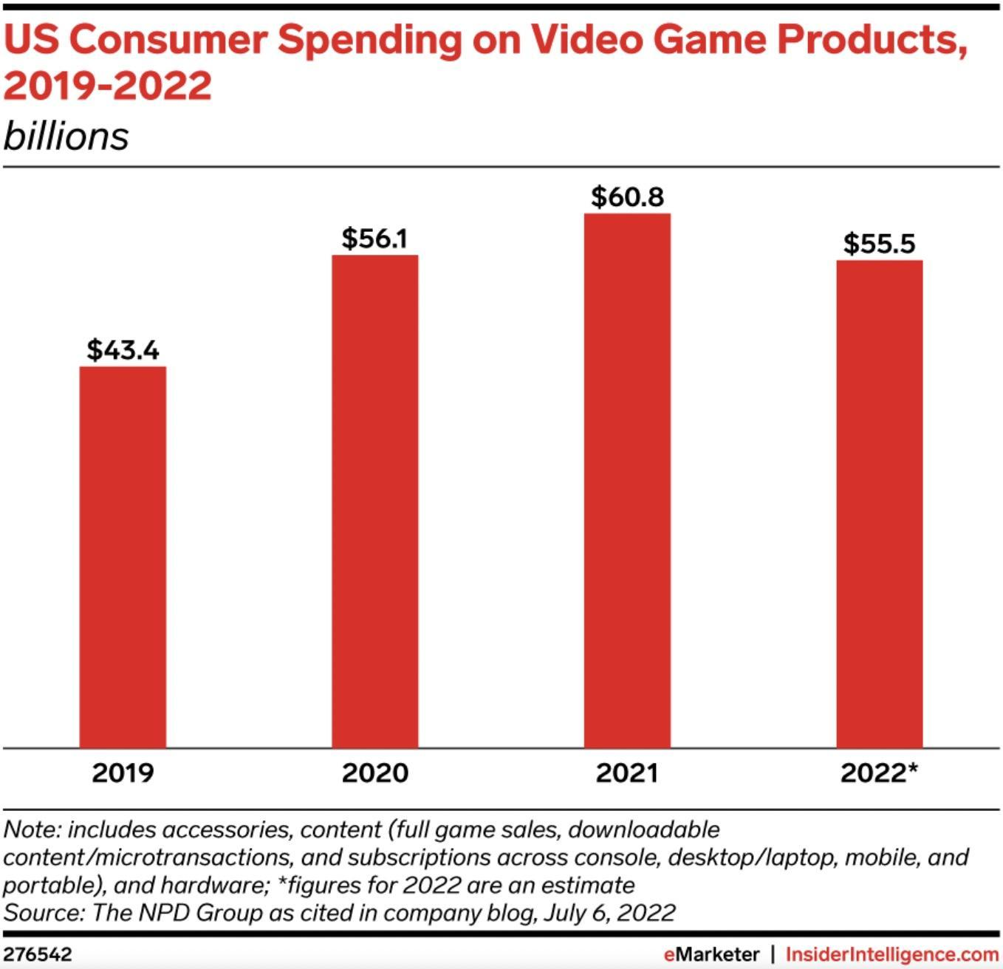

In fact, according to the NPD business research group, consumer spending in the US per year has grown by nearly 20 billion since the beginning of the pandemic in late 2019 and has continued to increase well into the middle of 2022. More specifically, the type of game demanded by consumers has largely shifted toward games with multiplayer capabilities; according to a report conducted by the major game developer Unity on the type of games demanded during the pandemic and moving past it, “More than half of the global population play games (52%), and 77% of them play multiplayer” (Efendioğlu, 2022). Psychologists suggest the shift towards multiplayer games is most likely due to the lack of real-life social interaction that gamers experienced during the pandemic compared to their previous amount of social interactions before the pandemic and has remained a prominent aspect of video games that gamers are attracted to (Gabbiadini-Durante 2020). Therefore, not only did the pandemic dramatically increase demand for video games overall, but it has also continued to shift the specific tastes of consumers in unique directions with potential psychological explanations.

However, the future of the video game industry is unclear; the industry clearly had a successful boom as a result of the pandemic, but will it continue to grow? Similar “stay-at-home” industries, such as streaming services, have recently taken a downward turn. According to Forbes, weekly viewership has dropped for nearly all streaming platforms over the past years since the pandemic, specifically mentioning Disney+ (down 5.4%), Hulu (down 4.6%), and Youtube (down 3.9%) since last year- 2022- *alone* (Fitzgerald 2023). Although part of this decrease in viewership and membership can be attributed to consumers allocating their income to inflated necessities as opposed to entertainment, consumers are also electing to seek the entertainment they can afford outside of their homes; the market quantity of movie tickets sold during the pandemic equated to less than two billion dollars in revenue, while in early 2023 the market has already supplied over seven and a half billion (Numbers Research, 2023). Therefore, as people face the trade-off between purchasing “stay-at-home” entertainment or entertainment elsewhere, one would expect that the video game market might follow suit with similar forms of entertainment such as streaming services. Despite this prediction, most forecasts of the video game market remain optimistic and the exact future remains unclear.

Thus, the Covid-19 pandemic severely shifted the consumer demand for entertainment such as video games and its effects are still evident in the market to this day. As video game producers scrambled to meet the boom in market demand and faced severe scarcity of production inputs, the demand for video games and video game complements similarly rose and helped move the video game market toward its highest levels of consumer spending in the market’s history. While the success of the market during and in the immediate wake of the pandemic’s end is evident, future market performance remains uncertain for the video game industry, despite similar industries already facing a decline in market success.

Works Cited

Efendioğlu, A. (2022, September 22). *Unity report states 77% of gamers play multiplayer games*. Game Industry News. Retrieved February 4, 2023, from https://mobidictum.biz/unity-report-states-77-percent-gamers-play-multiplayer/#:~:text=Unity%20has%20shared%20its%202022,77%25%20of%20them%20play%20multiplayer.

Fernandez, R. (2023, January 5). *Sony says its PlayStation 5 shortage is finally over, but it's still hard to buy*. NPR. Retrieved February 4, 2023, from https://www.npr.org/2023/01/05/1147157065/sony-playstation-5-shortage-over

Fitzgerald, T. (2023, January 30). *Surprise: More and more people are cutting their streaming TV services*. Forbes. Retrieved February 4, 2023, from https://www.forbes.com/sites/tonifitzgerald/2023/01/27/surprise-more-and-more-people-are-cutting-their-streaming-tv-services/?sh=30ace3a7292d

Gabbiadini A, Baldissarri C, Durante F, Valtorta RR, De Rosa M and Gallucci M (2020) Together Apart: The Mitigating Role of Digital Communication Technologies on Negative Affect During the COVID-19 Outbreak in Italy. Front. Psychol. 11:554678. doi: 10.3389/fpsyg.2020.554678

IBIS World. (2023, January 10). *Industry market research, reports, and Statistics*. IBISWorld. Retrieved February 4, 2023, from https://www.ibisworld.com/industry-statistics/market-size/video-games-united-states/#:~:text=The%20market%20size%2C%20measured%20by,to%20increase%209.4%25%20in%202023.

Insider Intelligence. (2023, January 25). *US video game industry: Trends & Forecast 2023*. Insider Intelligence. Retrieved February 4, 2023, from https://www.insiderintelligence.com/insights/us-gaming-industry-ecosystem/

Nussey, S. (2022, May 26). *Sony to ramp up PS5 production and broaden games portfolio*. Reuters. Retrieved February 4, 2023, from https://www.reuters.com/technology/sony-says-it-plans-ps5-ramp-up-shortages-ease-2022-05-26/

Research Numbers. (2023, January). *Movie market summary 1995 to 2023*. The Numbers. Retrieved February 4, 2023, from https://www.the-numbers.com/market/

Watson, R. T. (2021, March 19). *World-wide streaming subscriptions pass one billion during pandemic*. The Wall Street Journal. Retrieved February 4, 2023, from https://www.wsj.com/articles/worldwide-streaming-subscriptions-pass-one-billion-during-pandemic-11616079600

Winslow, L. (2022, August 1). *Sony says it'll pump out more ps5s for the holidays, so maybe you'll finally get one*. Kotaku. Retrieved February 4, 2023, from https://kotaku.com/sony-ps5-console-restock-christmas-black-friday-1849355305